**Introduction**:

**2.Background reseach:**

**2.1 Considerations for User Interface Design  
Input Method:**  
To enable users to make non-standard responses, input fields are a crucial component of user interface design. Although they are utilized in a variety of contexts, the majority of people have probably seen them when submitting online inquiries or entering personal information and delivery addresses on e-commerce web forms1. Various input field kinds and states have been found through input UI design exploration, along with style methods and usability advice for creating faultless user experiences.

**Common Gestures:**

Both Android and iOS come with gesture-based navigation. While Android 9 Pie keeps the on-screen home button, which is now shaped like a pill, iOS users may accomplish this by quickly swiping up from the bottom of the phone on the gesture bar. The system navigation on Android has a helpful return function that is really helpful from practically any screen. Creating an app meet the requirement for both platform is necessary

**Web apps against native apps and progressive web apps (PWAs):**

An application that is native to a mobile platform is one that can be obtained through an app store, such as the App Store, Google Play, or Galaxy Apps. Conversely, a program that runs within a web browser is known as a web app. A responsive website that offers an app-like experience is called a Progressive Web App (PWA). Progressive web applications operate in a browser and don't require downloading from an app store, which is the main distinction between them and native apps. In this situation, designing a native app is better than two option remains. Because, smart phone is the most popular in the world every one can have a phone so that native app is the effective way

**Screen Sizes:**

Designing for a variety of screen sizes and resolutions is a multifaceted process that calls for careful testing, technological know-how, and a user-centered approach8. The three main techniques for developing adaptable interfaces are adopting responsive design, giving mobile-first principles top priority, and optimizing media and images8. It is customary in adaptable design to create six designs: 320, 480, 760, 960, 1200, and 1600 pixels—for the six most popular screen widths. My design would take Iphone with 6.1 inch, it not too small and not too big.

**2.2 Usability/Design Guidelines and Standards**

**Jakob Nielsen and Rolf Molich’s Ten User Interface Guidelines:**

Companies like Apple, Google, and Adobe employ these standards extensively in the design of many of their successful products. Visibility of system status, compatibility between the system and the real world, user control and freedom, consistency and standards, error prevention, recognition rather than recall, ease of use and flexibility, minimalist and beautiful design, assistance for users in identifying, diagnosing, and recovering from errors, and help and documentation are some of the guidelines

**Usability Elements For Exceptional Experiences:**

These include error tolerance (supporting a range of user actions and only showing an error in genuine erroneous situations), effectiveness (assisting users in completing actions accurately), efficiency (enabling users to complete tasks quickly through the simplest process), engagement (engaging users and finding it appropriate for its industry/topic), and ease of learning (new users can accomplish goals easily and even more easily on future visits)  
**Design Principles:**

These are suggestions for using design principles to create a satisfying user experience. These consist of layout (list or grid structure), text (font, tone, labels/fields), style (colors, brand logos), accessibility (Aria markup for users with disabilities), and design patterns (forms).

I combine the Ten User Interface Guidelines and Usability Elements for Exceptional Experiences by Jakob Nielsen and Rolf Molich. These recommendations emphasize efficiency, error prevention, and user control—all of which are critical for any application that includes delivery and selection. They also place a strong emphasis on learning simplicity and engagement, both of which are critical for drawing in and keeping users. The ultimate choice, nevertheless, need to be made in light of the particular requirements and preferences of your intended user base. To make sure your design choices meet user wants and expectations, it's a good idea to carry out usability testing and user research

**3. User Group:**

The success of a user interface design largely depends on how well it caters to its user groups. For our food and recipe box delivery application, we have identified the following primary user groups:

**Heal-Conscious Individuals**

This group includes individuals who are conscious about their diet and prefer healthy and nutritious meals. They might be following a specific diet plan like keto, vegan, or gluten-free.

**Persona 1: Maria**

Maria is a 35-year-old yoga instructor who follows a strict vegan diet. She is always looking for new and exciting vegan recipes to try. She appreciates the convenience of having recipe boxes delivered to her home, saving her the time and effort of meal planning and grocery shopping.

**Key Facts:**

* They are conscious about what they eat and prefer meals that are healthy and nutritious.
* They may be following a specific diet plan and would appreciate meals that cater to their dietary needs.
* They value convenience and would appreciate a service that saves them time on meal planning and grocery shopping.

**Scenario:**

Maria is planning her meals for the upcoming week. She opens the app and filters the recipes to show only vegan options. She selects a few recipes that she finds interesting and orders the corresponding recipe boxes.

**Busy Professionals**

People in this category struggle to find time to prepare meals, buy for groceries, and cook because of their hectic work schedules. The ease of having meals prepared ahead of time and all the materials delivered right to their home would be greatly appreciated.

**Persona 2: John**

John is a 40-year-old lawyer who often works late hours. He wants to eat healthily but doesn’t have the time to plan meals and shop for groceries. He would appreciate a service that delivers recipe boxes that he can quickly cook at home.

**Key Facts:**

* They often work long hours and may not have the time or energy to plan meals and shop for groceries.
* They value convenience and would appreciate a service that saves them time on meal planning and grocery shopping.
* Despite their busy schedules, they want to eat healthily and would prefer meals that are nutritious and well-balanced.

**Scenario:**

John has a busy week ahead with several court appearances. He uses the app to select meals for the week and schedules a delivery. This way, he doesn’t have to worry about meal planning or grocery shopping during his busy week

**4. Visual Design**

**Color Scheme**

I’ve chosen black for text, white for background, and geen for clicked button.

Here is the Hex:  
**#FFFFFF,#0000000,#1ADB1E**

Black text and white background:  
A timeless combination that offers great contrast for readability is black text on white background. This is in line with the color theory principle of contrast, which says that designs with opposing hues are lively and visually appealing

Green clicked text  
The psychology of color can be connected to the usage of green for clicked text. Green is frequently linked to good behaviors and might indicate to the user that they have interacted with a section of the interface successfully



**Typography**  
For typography, it’s important to choose a font that is easy to read and aligns with the brand’s identity.

San Francisco:

is an Apple designed typeface that provides a consistent, legible, and friendly typographic voice. Across all Apple products, the size-specific outlines and dynamic tracking ensure optimal legibility at every point size and screen resolution. Numbers have proportional widths by default, so they feel harmonious and naturally spaced within the time and data-centric interfaces people use every day

Because design for Ios device there are no reason using that font.

**Layout**  
Making information accessible and comprehensible is the field of information architecture (IA). To assist individuals, comprehend their environment and locate what they're seeking for online and offline, it involves searching, browsing, classifying, and displaying pertinent and contextual information1. IA functions from two angles: Consumers view products, services, and information as linguistic spaces1. These locations, or information environments, can be set up to be as easily found and understood as possible. Context, users, and content all inform good IA  
The following may be the structure of the information architecture for your recipe box and meal delivery application:

**The home screen** is what consumers view when they launch an application. It could show highlighted recipes, best-selling meal kits, and exclusive deals.

**Recipe Selection**: Users can peruse several recipes using this screen. It may be divided into groups according to the kind of cuisine, nutritional requirements, length of preparation, etc.

**Meal Box Customization:** By choosing the recipes they wish to include; consumers may personalize their meal boxes on this screen.

**Checkout**: The user may verify their order and schedule delivery from this screen, which also gives them an overview of their meal box.

**Graphic Design Elements**  
The visual components that users interact with, such buttons, menus, and control panels, are known as graphic design elements. They are essential in designing engaging and intuitive user interfaces that let people move about and engage with the system. The following are some essential components of graphic design that you may use in your application:

**Buttons**: Buttons are interactive design components that a user may tap or click to start a certain action. You may include buttons, for instance, to add a recipe to the meal box or to check out.

**Icons**: Icons are a small, aesthetically pleasing way to represent various capabilities or functionalities. One may utilize an icon of a shopping cart for the checkout button, a heart for the favorites function, and so on.

**Visuals**: Having clear, crisp photos of the recipes may improve the app's aesthetic appeal and aid users in selecting.

**Badges**: Using badges as visual cues, you may express certain details about an item. To designate recipes that are gluten-free or vegetarian, for instance, you may utilize badges.

**5. Low-Fidelity**

**Alternative 1:**

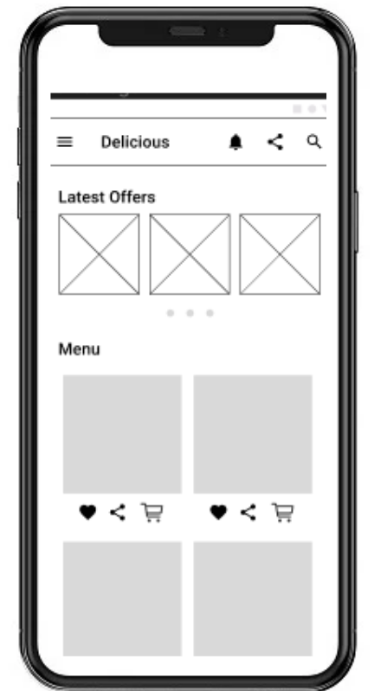

**Hamburger Navigation**

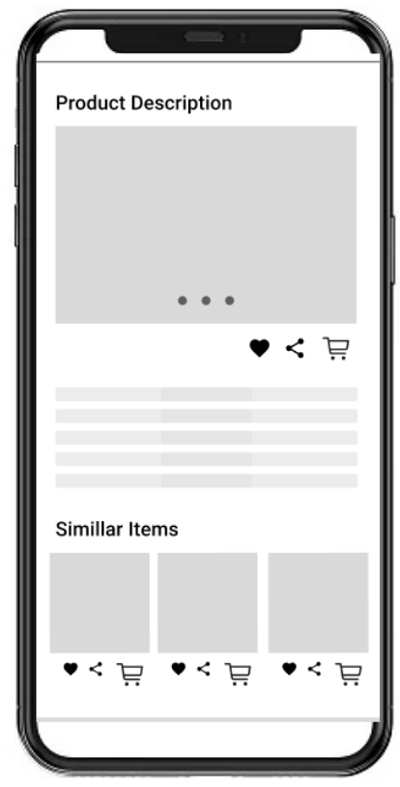This design I use Hamburger Navigation feature to link all the page such as: Home, Category, Login,....